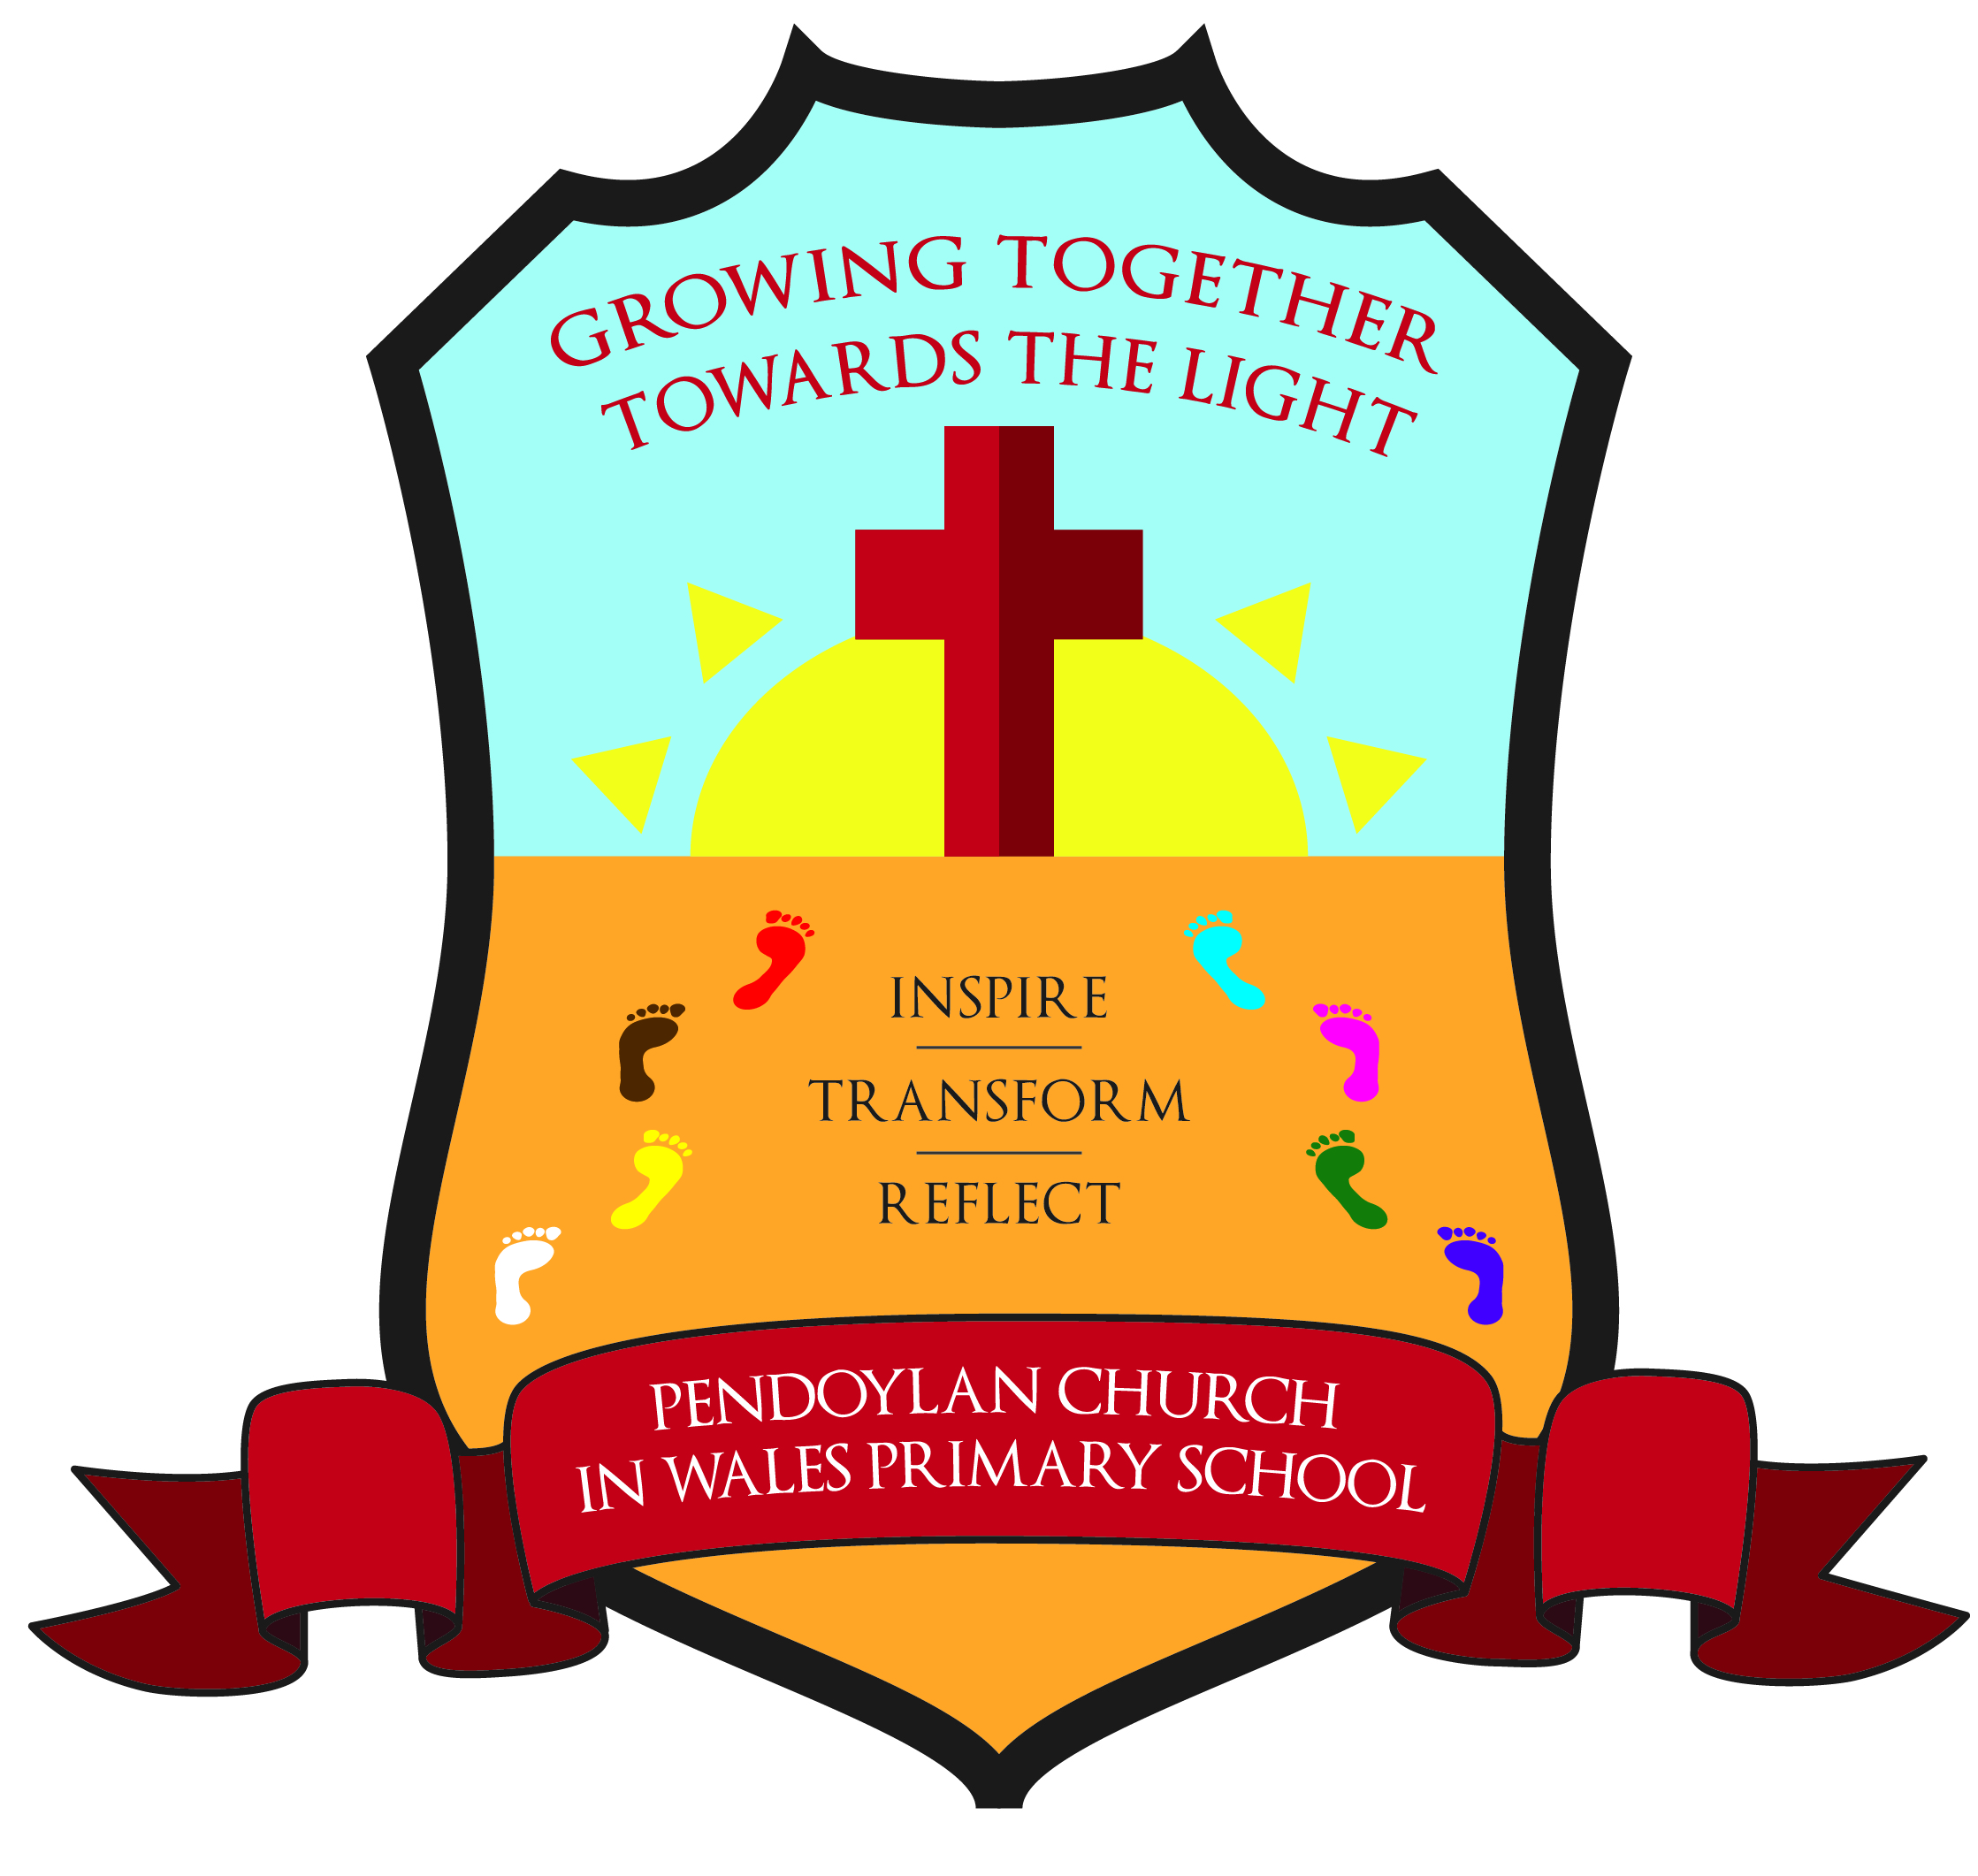
Pendoylan Church in Wales Primary School

Policy on Education for Sustainable Development and Global Citizenship (ESDGC)
At Pendoylan Church in Wales Primary School, we acknowledge that Education for Sustainable Development and Global Citizenship (ESDGC) equips students for the challenges of the 21st century. ESDGC should be integrated throughout the curriculum and all facets of school activities, fostering a sense of responsibility at the local, national, and global levels.

INTRODUCTION
Education for sustainable development and global citizenship is:
- the links between society, economy and environment and between our own lives and those of people throughout the world.
- the needs and rights of both present and future generations.
- the relationships between power, resources and human rights.
- the local and global implications of everything we do and the actions that individuals and organisations can take in response to local and global issues.
Education focused on Sustainable Development empowers our students to cultivate the knowledge and abilities necessary for making informed choices about our lifestyles.
Education for Global Citizenship equips our pupils with the understanding of values and skills essential for making decisions that advocate for a fair and sustainable global community.

ECO-CODE
In order to educate our pupils in sustainable and global issues we instil the following messages through an eco-code displayed in every class.
E – Every piece of litter can be picked up.
C – Collect all your rubbish.
O – Organise it to help reduce, re-usue, recycle.
C – Careful with taps, don’t leave them running.
O – Off is best for the lights when you are not around.
D – Don’t use anymore than what you need. Reduce your consumption.
E – Everybody can make a difference by following this code!

AIMS
At Pendoylan Church in Wales Primary School our aims are to:
- Enable pupils to learn how to care for and protect their environment. We strive to reduce pollution and use our natural resources with thought and care. We do this with the understanding that collectively, schools in Wales, the UK and globally, can make a huge difference. In all we do, we respond to the example of Jesus and remember that we are ‘here to serve and not to be served’.
- Help pupils to understand their own rights and responsibilities, as citizens locally and globally, and have respect for the rights and responsibilities of others. We strive to give them knowledge and understanding about our world and the people who live in it and to understand everyone’s relationship with the environment.
- Help pupils to develop the skills to be critical thinkers by giving them the facts. They are given a variety of resources so that they can have balanced information and can come to their own judgments.
- Celebrate cultural, religious and linguistic diversity and foster positive attitudes towards others who are different to us.
- If it is to succeed, ESDGC needs to be addressed by the whole school community, not just teachers and learners, but parents, carers, governors, visitors and non-teaching staff. ESDGC needs to be embedded across the curriculum and infused throughout the life of the school, this can be done with staff and the enforcement from eco-committee as well as other pupil voice groups.

OBJECTIVES (changed layout to add examples)
Our objectives in the teaching of ESDGC are:
Key Objective | Outcomes | Examples
Wealth and  Poverty | To enable the children to recognise that people should be entitled to have their basic needs met and to understand the effects of inequality on the quality of people’s lives. Local actions have effects in the wider world because of the connections between places and people. | Whole class teaching  Expedition  LLC Lessons  Fair Trade Fortnight  RVE  Healthy Schools
Identity and Culture | To enable the children to recognise the impact of discrimination and prejudice on individuals and groups. Recognise they are global citizens of an interconnected world and to understand we all have similarities and differences that people have differing beliefs and values, cultural values and religious beliefs shape the way people live. | Whole class teaching  Expedition  LLC Lessons  RVE  Pupil voice groups  International Links  Anti-bullying  Show Racism the Red Card  Fair Trade Fortnight
Choices and Decisions | To enable children to: participate in aspects of school life helping to make decisions. Express and enact respect for self and others, appreciate that personal actions have consequences. Question statements and opinions and look for evidence and to understand how to prevent and avoid conflicts, what is meant by the rights of the child and that not everyone has these, that environment can be affected by the decisions we make individually and collectively. | Whole class teaching  Expedition  LLC Lessons  RVE  Pupil voice groups  Class/School Rules  School Values  School Prefects
Health | To enable the children to: care for their own health and the health of others, recognise their responsibilities to keep themselves and others safe. Appreciate the importance of family and community when making health choices and to understand the basic ingredients of a healthy lifestyle the impacts of environment on health and wellbeing, poverty and inequality cause health problems and vice versa, the importance of access to clean water for health. | Whole class teaching  Expedition  LLC Lessons  PHSE
Natural Environment | To enable children to: develop respect for landscapes, habitats and living things. Develop a fascination with and respect for the natural world and to understand: the needs of living things, people depend on the environment for energy, food and other materials and resources. | Whole class teaching  Expedition  LLC Lessons  RVE  Pupil voice groups  Environmental Review  Outdoor Learning
Consumption and Waste | To enable the children to: take personal action and influence others to save energy reduce consumption. To understand: where the things people consume come from and go to, ways to reduce their energy use and the energy use of others. That waste can cause pollution. | Whole class teaching  Expedition  LLC Lessons  RVE  Pupil voice groups
Climate Change | To enable the children to: to recognise that individuals and groups can take action to educate and campaign. That there is a range of views as to how best combat climate change and to understand: climate can change with time, the range of ways to both save and generate energy, the difference between climate and weather.  To enable children to know and understand environmental problems at a local, regional and global level.  To encourage in children a commitment to sustainable development, and an appreciation of what ‘global citizenship’ means.  - To develop in children a variety of other skills, including those of enquiry, problem-solving, ICT, investigation, and that of presenting their conclusions in the most appropriate way to develop the cross-curricular use of ESDGC in all subjects. | Whole class teaching  Expedition – using ICT for data handling  LLC Lessons

The contribution of ESDGC to teaching in other curriculum areas – mentioned in examples above
LLC Lessons
ESDGC makes a significant contribution to the teaching of Language, Literacy and Communication in our school because it actively promotes the skills of reading, writing, speaking and listening. We ensure that some of the texts that we use in the literacy hour are ESDGC in nature. At Key Stage 2, we organise debates on environmental issues, because we believe that these develop speaking and listening skills. Reports, letters and recording information will all develop children’s writing ability. We also use environmental issues as a way of developing the children’s writing ability, by asking them to record information and write reports and letters.
Maths and Numeracy
The teaching of ESDGC in our school contributes to children’s mathematical understanding in a variety of ways. We teach the children how to collect data and represent data. They also use graphs to explore, analyse and illustrate a variety of data.
Personal, social and health education (PSHE) and citizenship
ESDGC contributes significantly to the teaching of personal, social and health education and citizenship. Firstly, the subject matter lends itself to raising matters of citizenship and social welfare. For example, children study the way in which people recycle material, and how environments are changed for better or for worse. Secondly, the nature of the subject means that children have the opportunity to take part in debates and discussions. We allow them to organise campaigns on matters of concern to them, such as helping poor or homeless people. Thus, ESDGC in our school promotes the concept of positive citizenship.
RVE – Religion, Values and Ethics
We offer children in our school many opportunities to examine the fundamental questions in life through the medium of ESDGC. For example, their work on poverty of children. We encourage the children to reflect on the impact of mankind on our world, and we introduce the concept of ‘stewardship’ in relation to sustainable development. Through teaching about contrasting localities, we enable the children to learn about inequality and injustice in the world. We help children to develop their knowledge and understanding of different cultures, so that they learn to avoid stereotyping other people, and acquire a positive attitude towards others. We help contribute to the children’s social development by teaching them about how society works to resolve difficult issues of economic development. ESDGC contributes to the children’s appreciation of what is right and wrong by raising many moral questions during the programme of study.

Compiled by : Mrs Whitfield , ECO Co-ordinator

Signed Headteacher – Mrs P M Vaughan Date = Autumn 2024

Review date = Autumn 2026

